Walk 16 Athelstan’s Wood
Last walked in July 2019

Description. An 8 km (5 mile) strenuous walk over undulating farmland and woodland. Athelstan's Wood is an ancient wood named after a Bishop of Hereford in 1056.
Start. From St David's church, Little Dewchurch, 5½ miles south east of Hereford. Explorer Map 189 Grid 529317
Directions from Belmont roundabout. (Turn milometer to zero). Take the A49 to Ross-on-Wye and at 3 of a mile, (528 yds), TL at traffic lights and head towards Holme Lacy on the B4399. At 6 of a mile, (500 yds), TR at mini roundabout signed ‘Dewchurch 5’. In Little Dewchurch, after 54 miles TR signed ‘St David’s Church’. After 58 miles park in the lay-by at the church.

1. St David’s Church. St David's, Little Dewchurch, is a small village church set in the beautiful countryside of South Herefordshire on the edge of the Wye Valley. It has a medieval tower (14th century) housing six bells that are rung regularly. The rest of the church was designed and rebuilt by the architect and artist Frederick Preedy in 1869-70. With your back to the church take the road to your R, after 30 metres the road bends L, follow the road gently uphill for a while, and just before the road bends to the R you TL and cross over a stile into F1. Walk 40 metres downhill, keeping to the fence on your R, to TR over a stile/gate and into F2. Follow the pylons and the delightful stream on your L, to cross over a stile into F3, and continue along the bank of the stream. At the bottom L hand corner of F3 you dog-leg L then R to reach the track that crosses the stream. Do not cross the stream but turn R into F4, and follow the track uphill, with a hedge on your R, to join a short enclosed muddy lane into the farmyard. Go straight ahead thru the yard, with one or more gates, to rejoin the road that’s coming from the church.

2. Church lane. Go straight ahead, down the road to the bottom of the hill and TR onto a track that has a metal gate and stile 40 metres ahead. Cross the stile and continue on for 30 metres then TL at the first footpath, to go uphill along the edge of the wood and thru a small wooden gate into F5. Go straight ahead and to the L of three oak trees. Near the oak trees, on your L hand side, you meet up with a hedge, keep it on your L and follow it to a gate and stile in the corner of the field. Cross the stile onto a road. Turn sharp R onto an enclosed stony track, which becomes an enclosed green lane, and follow it for about 1½ km, ignoring all other paths or tracks to R and L. The track may narrow in places if the grass and weeds on either side have grown, but eventually the track becomes more defined and will turn into a lane/road as you continue on to reach St Mary’s church of Little Birch, which is on your L.

3. St Mary’s Church. Immediately after the church TR down a track to reach Higgin’s Well at the bottom. The well was restored for Queen Victoria’s Diamond Jubilee in 1897. Legend has it that the landowner tried to stop local people drawing water from it but after his own house was flooded he relented and the well has never run dry since! Now TL to take the uphill track behind the well. A short stretch of this can be muddy, though some stepping stones are provided. Carry on to the main road and TR, walk a few paces and TR to follow the No Thru road/Unsuitable for HGVs uphill. The road bears L and continues uphill for about 1km to the T junction where you TR.

4. T Junction. TR here. Continue along this road, (passing a house on your R called Green Lea Cottage, or Bwthyn Tir Glas in Welsh), and go
straight ahead thru a metal gate that’s across a grassy track. Follow this track gently down hill to reach its end, at a metal gate. Go thru two metal gates
and continue in the same direction, with newly planted trees on your L and sawed down trees on your R. Follow the path into the trees to a T-junction of tracks, where you TL and walk along a wider forest track. Follow the track downhill, the track swings to the R and runs parallel with a stream on your L. Continue downhill for about ½ km to a track junction where a track to the L crosses the stream by a culvert.

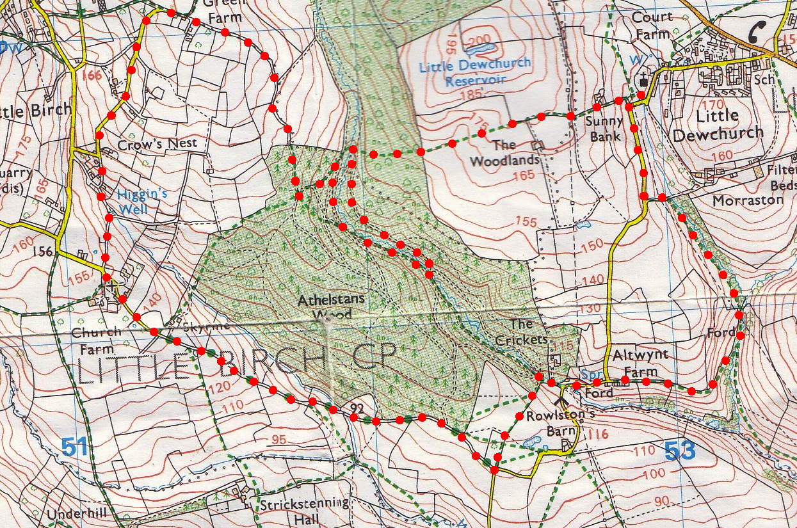
5. Culvert. A culvert is a device used to channel water. It may be used to allow water to pass underneath a road, railway, or embankment. In forestry, proper use of cross-drainage culverts can improve water quality while allowing forest operations to continue. Cross the stream and turn sharp L to follow the track uphill, the stream is now below you on your L. Continue on for about ½ km to reach a clearing in the track, a sort of car parking area. Go to the far end of the clearing and just before reaching a gate turn sharp R to go up a way marked path that goes thru the woods. Go thru the wood to reach the other side and cross a stile into F6. Head slightly R to cross this field, heading toward the R side of an electric pylon. At the end of the field go thru a gap into F7 and walk along the R field edge, with the hedge on your R. In the Field corner you go thru hedge gaps into F8, a hedge and 2 sets of stiles are on your L as you continue down hill to a tarmac lane. Go down hill to the road junction and TL to the car park.
4
1
2
3
4
5

